Modigliani, Amedeo Clemente (1884-1920)

Defying categorisation, the Italian draughtsman, painter and sculptor Amedeo Modigliani is a key representative of the School of Paris. Active in France from 1906 until his premature death in 1920, he placed the human body at the centre of his work. With few exceptions his approximately thirty sculptures comprise of crouching figures and elongated heads and his approximately four hundred and twenty paintings are portraits and female nudes. Less experimental and radical than some of his contemporaries, Modigliani never questioned the human form. Rather, drawing on his early training in Italy, he continued the great tradition of the female nude in modern, provocative reinterpretation. His only solo exhibition during his lifetime, shown at Galerie Berthe Weill in Paris in 1917, caused a scandal: Featuring his great series of reclining female nudes, the exhibition was closed by the police on the grounds of obscenity, but subsequently reopened. Modigliani’s private life was no less dramatic; despite or because of his poor health, he indulged in alcohol, drugs and women. His last love was the art student Jeanne Hébuterne, fourteen years his junior. She was nearly nine months pregnant with their second child when Modigliani died age thirty-five of tubercular meningitis in 1920. Desperate and inconsolable, Hébuterne committed suicide the day after, killing herself and the unborn child.
Modigliani was born into a culturally sophisticated but no longer prosperous Jewish family in Livorno in 1884. His early life was overshadowed by bouts of severe illness. Frequently bed-ridden, he started to draw and paint early, discontinued his school education at the age of fourteen, and then studied with the plein-air painter Guglielmo Micheli in Livorno. Following his introduction to the themes and styles of 19th-century Italian art, Modigliani set out to explore the Renaissance masters. His travels first took him to the south of Italy and Rome, where he sketched in galleries, and then to Florence and Venice, where he studied life drawing and oil painting. In 1906, following three years of study at the Accademia di Belle Arti in Venice, he moved to France.
In Paris, Modigliani first settled in Montmartre; he continued his studies at the Académie Colarossi, moved in artistic circles where he met Pablo Picasso and other members of the avant-garde, and soon refashioned himself from academic to bohemian painter. From 1907 he enjoyed the patronage of the collector Dr Paul Alexandre and exhibited at the Salon des Artistes Indépendants and the Salon d’Automne. Following another bout of illness and a brief return home to Livorno, Modigliani moved to Montparnasse, where he became friends with other expatriate artists, amongst which Chaïm Soutine, Moïse Kisling and Jacques Lipchitz. In 1909 Modigliani was introduced to Constantin Brancusi and, after some first attempts in 1902, again turned to sculpture. Brancusi inspired him in terms of his unassailable artistic independence and with his smooth stone carvings, characterised by their almond-shaped eyes, thin noses and small mouths. Modigliani’s elongated Head (c.1911-12), carved in limestone, shows the influence of Brancusi, but also of African, Khmer and other ‘primitive’ non-European sculpture as he may have seen in the studio of Brancusi, Lipchitz or Picasso. Suffering again from ill health and increasingly sensitive to dust, Modigliani returned to painting in 1913-14 in which he translated his sculptural concerns – elongated form, clear lines, flat spaces and rhythmic vitality – onto canvas.

While Modigliani may be best known for his reclining female nudes, of which he painted at least twenty-six, the vast body of his painterly output were portraits, often showing artist friends. One of his most naturalistic and penetrating character studies is that of his close friend Soutine, painted in 1917. In the same year, encouraged by his art dealer and friend Léopold Zborowski, he produced and exhibited his great series of reclining female nudes, echoing Titian in subject-matter and Botticelli in line. Like in the other paintings in this series, however, the female nude in Nude with Necklace diagonally spanned across the canvas close-up and peacefully asleep, is presented devoid of any mythological context. Unlike his precursors and contemporaries, Modigliani thus portrayed the female nude in a bold and provocative manner, often dramatically set against a dark background.

Having exhibited only little during his lifetime, it was Zborowski and the art critic and poet André Salmon who established Modigliani’s posthumous reputation: Zborowski organised a retrospective in the Galerie l'Evêque in Paris in 1921 and Salmon published a biography of the artist in 1926.

References and further reading:

Belli, G. et. al. (eds.) (2010), Modigliani Sculptor, Milan: Silvana (exh. cat.).

Braun, E. et. al. (eds.) (2006), Modigliani and his Models, London: Royal Academy (exh. cat.).

Grenier, C. and D. Marchesseau (eds.) (2013), Modigliani et l'Ecole de Paris, Martigny: Fondation Pierre Gianadda.

Klein, M. (ed.) (2004), Modigliani: Beyond the Myth, New Haven & London: Yale University Press (exh. cat.).

Modigliani, J. (1958), Modigliani senza leggenda, Florence: Vallecchi.

Parisot, C. (1990), Modigliani: catalogue raisonné, Livorno: Graphis Arte.

Pfannstiel, A. (1956), Modigliani et son œuvre: étude critique et catalogue raisonné, Paris: Bibliothèque des Arts. [Originally published under the title Modigliani in 1929].

Wayne, K. (2002), Modigliani and the Artists of Montparnasse, New York: Harry N. Abrams (exh. cat.).

Image suggestions:

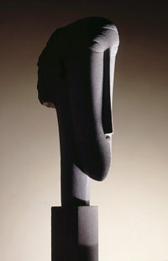

Amedeo Modigliani, Head, c. 1911-12. Limestone, 89.2 x 14.0 x 35.2 cm. Tate, London.

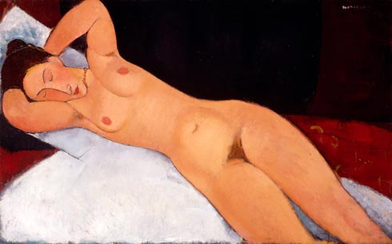

Amedeo Modigliani, Nude with Necklace, 1917. Oil on canvas, 73.0 × 116.7 cm. Solomon R. Guggenheim Museum, New York.

